GENERAL LAYOUT



This will be the general layout for all pages.

First icon indicates the lists of songs created by user.

Second icon gives list of all songs, categorized as folders.

Third icon is for Holy mass prayers.

There is also a sidebar and a more option icon

Side bar of the application – For every window



APP NAME V 2.1.1

Request New Song

Holy Mass Prayers

My List

Songs

Entrance

Psalm

Gospel

Offering

Osana

Elavation

Communion

Others

About

By default, expand songs list

App Home Screen



All Songs

Report Error

Report Error

Gospel

Entrance

Pslam

Entrance

Pslam

Gospel

Elavation

Offering

Osana

Offering

Elavation

Osana

Others

Communion

Others

Communion



Note the position of the search bar

Provide different styles as themes in settings

Search bar and options



Song title **X**

Song title **X**

Song title 001 - Genre 01

Song title 002 - Genre 01

Song title 001 - Genre 03

Song title 001 - Genre 02



Add to list

Song title 001 - Genre 01

Song title 002 - Genre 01

Song title 001 - Genre 03

Song title 001 - Genre 02



Add to list

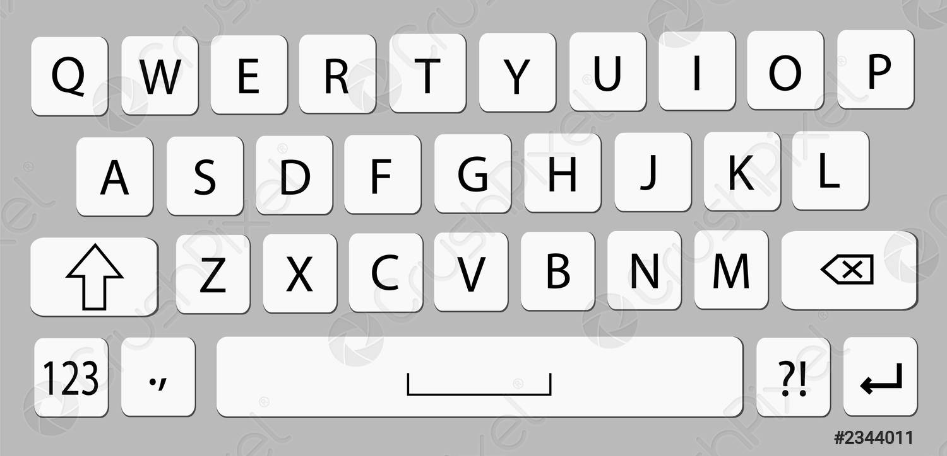

Search results must display song genre

Take care of the background (Show search bar on top of current page or show it as a separate page.) (Better to animate and go to another page)

Add to list feature given an option to add current song to an already existing list of songs, or create new list.

Define number of search results

Add to list

This feature when clicked displays all lists created by the user, also allows to create new list.

If current song is already present, then show error message.

After adding the song to a list, show a bottom bar to view the edited list. (Optional req.)

Entrance

Pslam

Others

Elavation

Gospel

Offering

Osana

Communion

Song has been added View List



Communion

Osana

Offering

Gospel

Elavation

Others

Pslam

Entrance

Song has been added View List

Song has been added View List



Consider providing an option to change the view of folders to lists. ( Optional – future)

Search bar alterative

Song has been added View List

Song has been added View List



Entrance

Pslam

Others

Elavation

Gospel

Offering

Osana

Communion

Individual Folder View

**GOSPEL**



**GOSPEL**

Song 001 with full title and

The line extends

Song title 002

Song title 004

Song title 003



Song title 004



Song title 004



Song title 004



Song 001 with full title and

The line extends

Song title 002

Song title 004

Song title 003



Song title 004



Song title 004



Song title 004



There can be an option to add a song to a list by long pressing that song.

After adding the song to a list, show a bottom bar to view the edited list.

Search function is same as the home screen except that it will search only the songs in the current folder.

**Lyrics Page**



hN\§fêfq ssZhta Xnêþ

hN\§fêfq ssZhta

tImdkv:

hN\§fêfq ssZhta Xnêþ

hN\§fêfq ssZhta

Imgv¨bmw hN\w tIÄhnbmw hN\w

I®oê amíp¶ hN\w (2)

Xncsb apdns¨¯pw sNdph©n t]mse

ISeeIfnsÃmgpInhêw hN\w (2)

tImdkv:

lseeqb lm lm lseeqbm (3)

lseeqbm... lseeqbm....

]mXbmw hN\w ]mh\ hN\w

]mcnsâ Zo]amw hN\w (2)

Song Title 001

Chord: G

**GOSPEL**

Add to list

Report Error

DETAILS

LYRICS

This page contains two tabs. One for lyrics and another for music link or music details.

Music Details tab.



Karaoke

Music Track

Song Name: Song title 001

Album: Song album

Genre:

[ Optionals ]

Singers:

Year:

Root chord:

**GOSPEL**

LYRICS

DETAILS

Consider how to control music playback when moving to other pages. (Use an icon like the search icon at the bottom)

Add an option to suggest new karaoke or music link ( Optional - future)

*Lists Page*



New List

Report Error



List 001

List 003

List 002

List 004



List 001

List 003

List 002

List 004



LISTS

LISTS

Decide position of new list creation menu

Create new list

OK

CANCEL

Enter here

Enter the new list name



Consider blurring the background while creating the list.

After creation, go to the new list page and suggest user to add songs.

On long press on a list item



LISTS - EDIT

1 item selected

LISTS - EDIT

1 item selected



List 001

List 003

List 002

List 004



List 001

List 003

List 002

List 004



Note that there is no more button while editing the lists.

Book with plus icon helps to assign current list to holy mass prayers ( iff one list is selected, else disable it)

Individual list view

Add song

Report Error

List name 001

Song 001 with full title and

The line extends – Genre 002

Song title 002 – Genre 001

Song title 004 – Genre 003

Song title 003 – Genre 002



Song title 004 – Genre 004



Song title 004 – Genre 005



Song title 004 – Genre 006



Song 001 with full title and

The line extends – Genre 002

Song title 002 – Genre 001

Song title 004 – Genre 003

Song title 003 – Genre 002



Song title 004 – Genre 004



Song title 004 – Genre 005



Song title 004 – Genre 006



List name 001



List page when clicked on edit button

List name 001 - Edit

Song 001 with full title and

The line extends – Genre 002

Song title 002 – Genre 001

Song title 004 – Genre 003

Song title 003 – Genre 002



Song title 004 – Genre 004



Song title 004 – Genre 005



Song title 004 – Genre 006



The list items/songs can be re-positioned using the three line icon.

Here the close icon act as back button

Adding new songs to the existing list.

After clicking on add new songs icon, go to folder page.

Add songs - Entrance

Add songs

Song 001 with full title and

The line extends – Genre 002

Song title 002 – Genre 001

Song title 004 – Genre 003

Song title 003 – Genre 002



Song title 004 – Genre 004



Song title 004 – Genre 005



Song title 004 – Genre 006



Entrance

Pslam

Others

Elavation

Gospel

Offering

Osana

Communion

Show the songs as marked which is already present in the list or which are newly selected.

After ok button, show the newly created list or the lists page.

When click on the number icon at bottom try to show list of selected songs

Song 001 – Genre 002

Song title 002 – Genre 001

Song title 004 – Genre 003

Song title 003 – Genre 002



Song title 004 – Genre 004



Song title 004 – Genre 005



Song title 004 – Genre 006



Add songs - Entrance

Take care of the background.

The cancel button (x) is optional for the list

Request new song Page Report Error Page

Report Error

New song

CATEGROY

TITLE

DESCRIPTION

GENRE

ALBUM (OPTIONAL)

MUSIC LINK

KARAOKE LINK (OPTIONAL)

SUBMIT

SUBMIT



Back button: Back to homepage

The category in error page is possibly a dropdown list. Also the genre in new songs

Consider removing the bottom icons

Holy mass Prayers page On editing a song



ADDITIONAL

NORMAL

Song 001 with full title and

The line extends – Genre 002

Song title 002 – Genre 001

Song title 004 – Genre 003

Song title 003 – Genre 002



Song title 004 – Genre 004



Song title 004 – Genre 005



Song title 004 – Genre 006



Edit song - Entrance

KARTHAVE MAMA RAJAVE

Lorem ipsum dolor sit amet, consectetur adipisicing elit. Aut nesciunt voluptates inventore officiis nostrum possimus fugiat a

utem, reiciendis laudantium sequi beatae porro incidunt ipsam quibusdam velit officia? Modi quos delectus ipsa laborum

praesentium, eum non in cum cumque magnam optio consectetur, vero quasi recusandae? Rerum laboriosam praesentium sed accusantium architect.

reiciendis laudantium sequi beatae porro incidunt ipsam quibusdam velit officia? Modi quos delectus ipsa laborum praesentium, eum non in cum cumque magnam optio consectetur, vero quasi recusandae? Rerum laboriosam

SWARGASTHITHANAM TAHTA NIN

ANNAPESAHA THIRUNALIL

ENTRANCE SONG

Prayers

On clicking a song link



Song Title 001

Chord: G

hN\§fêfq ssZhta Xnêþ

hN\§fêfq ssZhta

tImdkv:

hN\§fêfq ssZhta Xnêþ

hN\§fêfq ssZhta

Imgv¨bmw hN\w tIÄhnbmw hN\w

I®oê amíp¶ hN\w (2)

Xncsb apdns¨¯pw sNdph©n t]mse

ISeeIfnsÃmgpInhêw hN\w (2)

tImdkv:

lseeqb lm lm lseeqbm (3)

lseeqbm... lseeqbm....

]mXbmw hN\w ]mh\ hN\w

]mcnsâ Zo]amw hN\w (2)



Song Title 001

Chord: G

hN\§fêfq ssZhta Xnêþ

hN\§fêfq ssZhta

tImdkv:

hN\§fêfq ssZhta Xnêþ

hN\§fêfq ssZhta

Imgv¨bmw hN\w tIÄhnbmw hN\w

I®oê amíp¶ hN\w (2)

Xncsb apdns¨¯pw sNdph©n t]mse

ISeeIfnsÃmgpInhêw hN\w (2)

tImdkv:

lseeqb lm lm lseeqbm (3)

lseeqbm... lseeqbm....

]mXbmw hN\w ]mh\ hN\w

]mcnsâ Zo]amw hN\w (2)

Take care of the side menu bar icon and more icons.

Or just make it classic (song lyrics within the prayer) (Not recommended, attach with a theme)





NORMAL

Lorem ipsum dolor sit amet, consectetur adipisicing elit. Aut nesciunt voluptates inventore officiis nostrum possimus fugiat a

Annapesaha thirunalil

Karthavaruliya kalpana pol

Thirunaamathil chernneedam

Orumayodeebaliyarppikkam

Anurangitharaay Theernneedam

Navamoru peedamorukkeedam…

utem, reiciendis laudantium sequi beatae porro incidunt ipsam quibusdam velit officia? Modi quos delectus ipsa laborum

praesentium, eum non in cum cumque magnam optio consectetur, vero quasi recusandae? Rerum laboriosam praesentium sed accusantium architect.

reiciendis laudantium sequi beatae porro incidunt ipsam quibusdam velit officia? Modi quos delectus ipsa laborum praesentium, eum non in cum cumque magnam optio consectetur, vero quasi recusandae? Rerum laboriosam

ENTRANCE SONG

NORMAL

PRAYERS

ADDITIONAL

PRAYERS

ADDITIONAL

PSALM SONG

The lyrical view for external songs like entrance, psalm etc. remains same, a separate page with a bottom close button.

The Additional tab is not defined yet. It contains prayers which varies with time (eg. Kaithakkalam, Eliya sleeve moosa kaalam, Uyirppukaalam etc.)

It also contains karososa prayers (Either give links like lyrics and show prayers on a popup page.)

Splash screen – not decided

